Student Details
Student Name: BENSON MUSAU
Admission Number: BSCCS/2023/51379
Course/Class: COMPUTER SCIENCE
Unit Code: BIT4138
Unit Name: Advanced Cryptography
Lecturer Name: NYORO MICHAEL
Semester/Academic Year: 2026
Project Details

Project Title: Advanced cryptographic decryption and encryption System

Selected Technologies: Python

GitHub Link
https://github.com/benmusau/BIT4138AdvancedCryptography.git

Table of Contents
Student Details 1
Week 1: Cryptography Environment Setup 6
Title: Installation and Configuration of Cryptography Development Environment 6
Fig 1: Installation of Python and VS Code 6
VS Code 6
6
Python 7
7
Fig 2: Installation of Cryptography Libraries 8
Fig 3: OpenSSL Installation Test 9
Fig 4: Local Encryption Script Execution 10
Fig 5: GitHub Repository Initialization 11
REFLECTION 11
Week 2: Classical Cryptography and Cipher Design 12
REFLECTION 15
Week 3: Stream Ciphers and Randomness Testing 16
Reflection 19
Week 4: Block Cipher Design and AES 19
REFLECTION 20
Week 5: Public Key Cryptography (RSA) 21
REFLECTION 22

Week 1: Cryptography Environment Setup

Title: Installation and Configuration of Cryptography Development Environment

Fig 1: Installation of Python and VS Code

VS Code

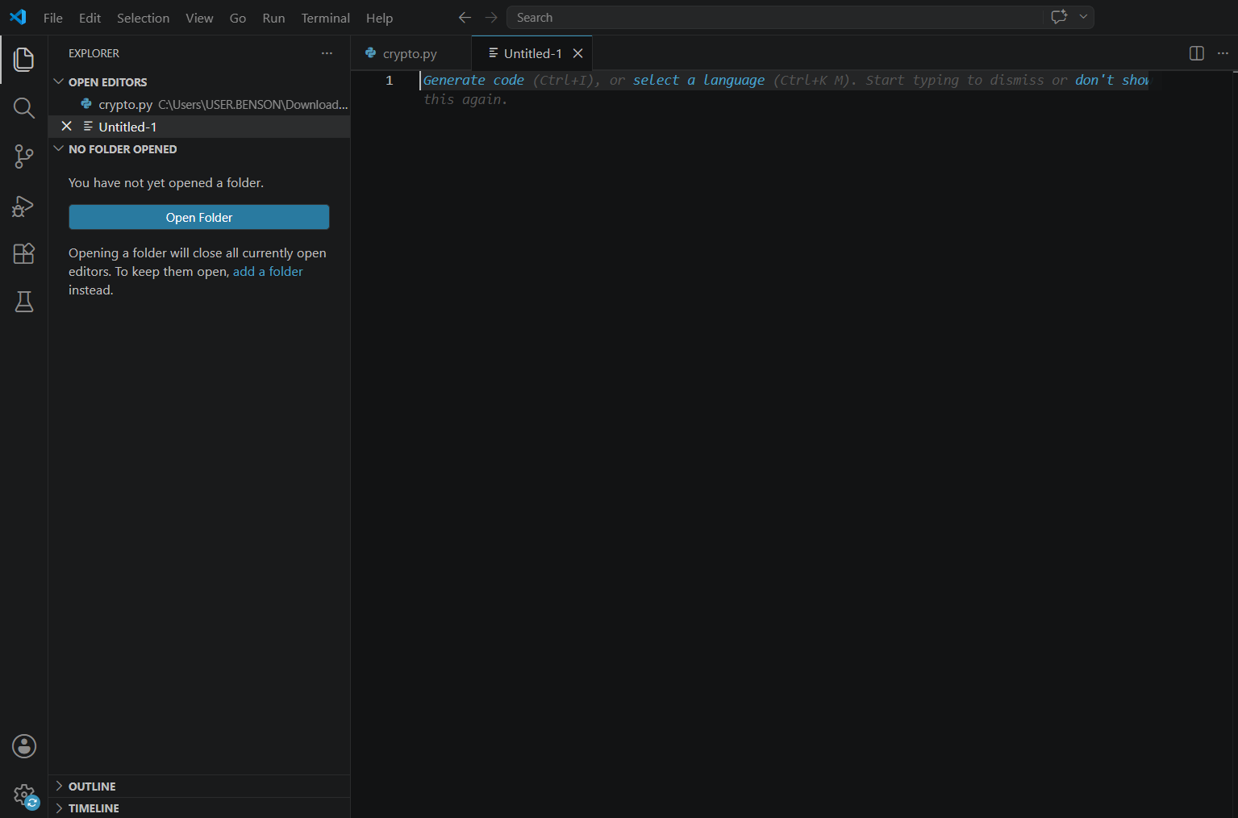

Python

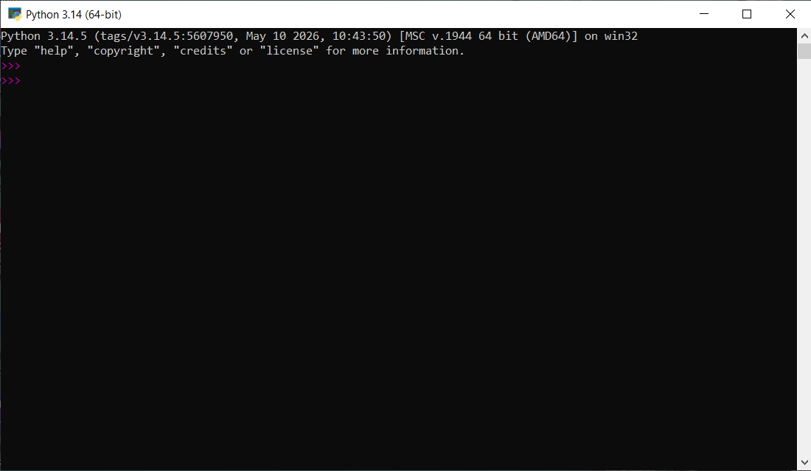

Fig 2: Installation of Cryptography Libraries
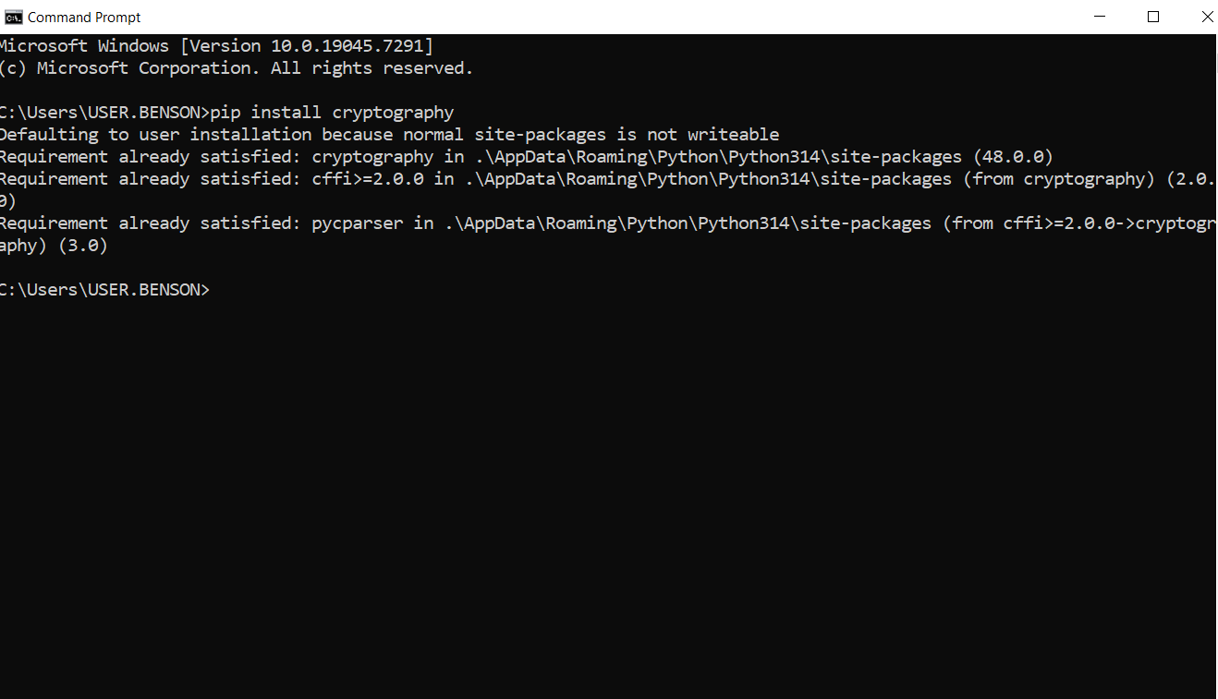

Fig 3: OpenSSL Installation Test
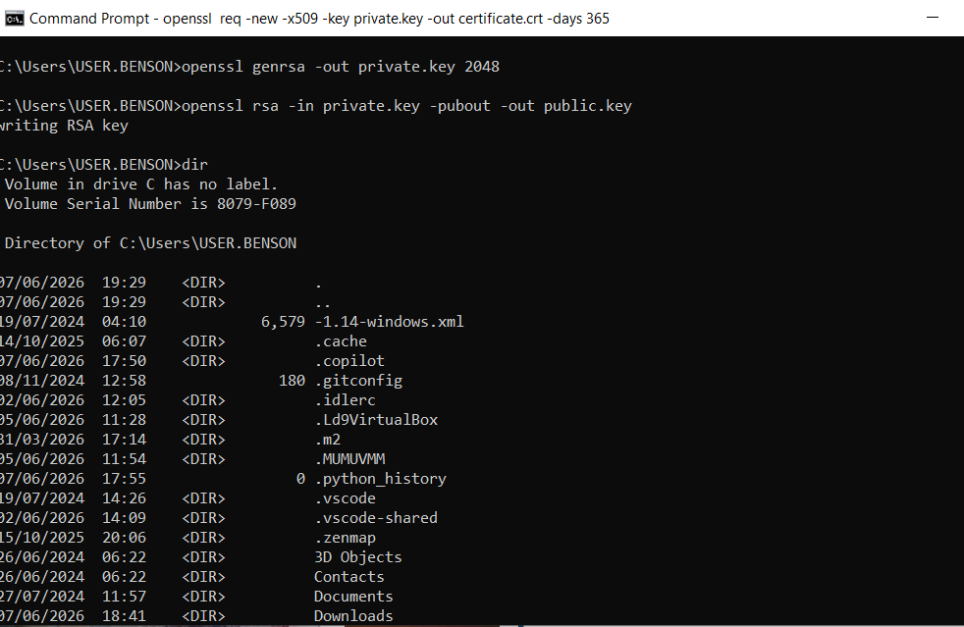

Fig 4: Local Encryption Script Execution
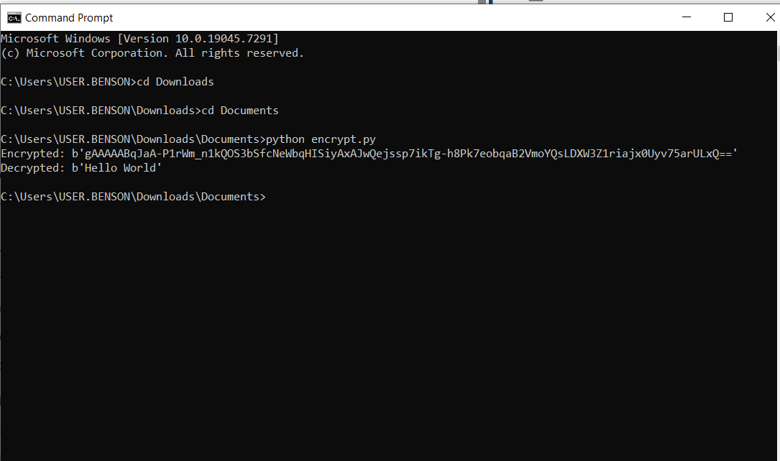

Fig 5: GitHub Repository Initialization
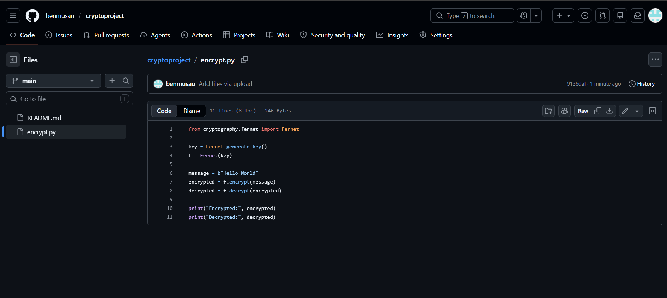

REFLECTION
I learned how to implement cryptographic techniques using Python and OpenSSL. Security tools configured include OpenSSL and a Python encryption script. The screenshots demonstrate successful setup, Fig 1: Installation of Python and VS Code, Fig 2: Installation of Cryptography Libraries, Fig 3: OpenSSL Installation Test fig 4: encryption execution, and fig 5: GitHub repository initialization. Challenges included installation errors and command usage.

Week 2: Classical Cryptography and Cipher Design
Title: Implementation of Classical Encryption Algorithms
Fig 1: Caesar Cipher Implementation
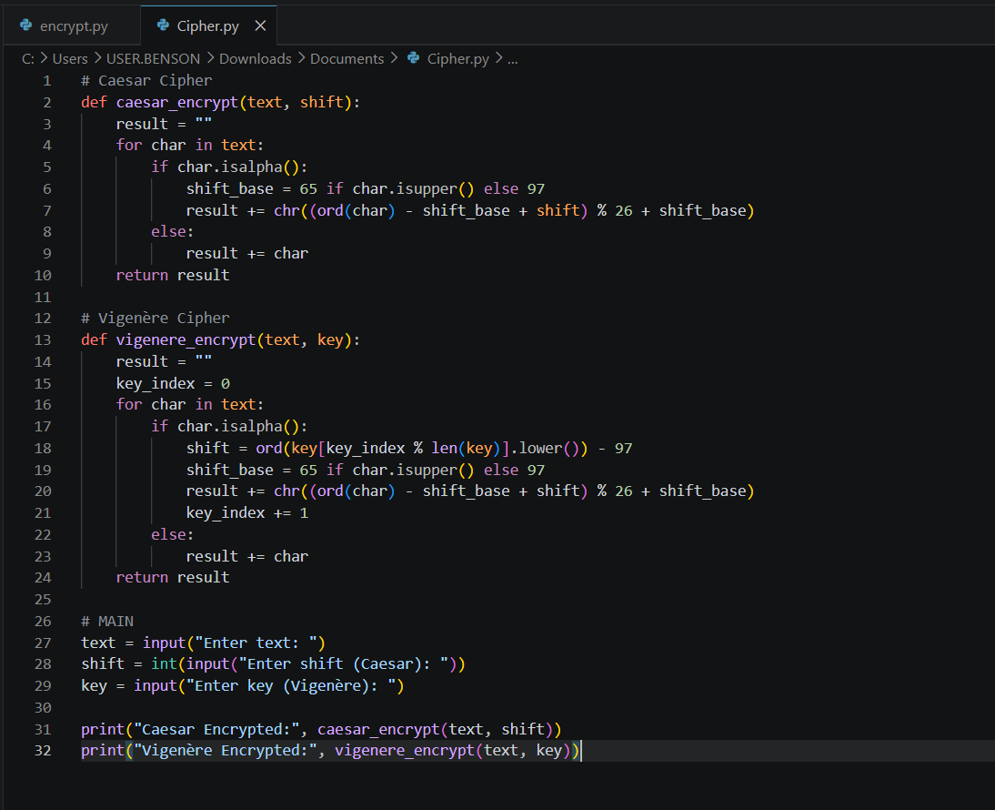

Fig 2: Vigenère Cipher Encryption Process
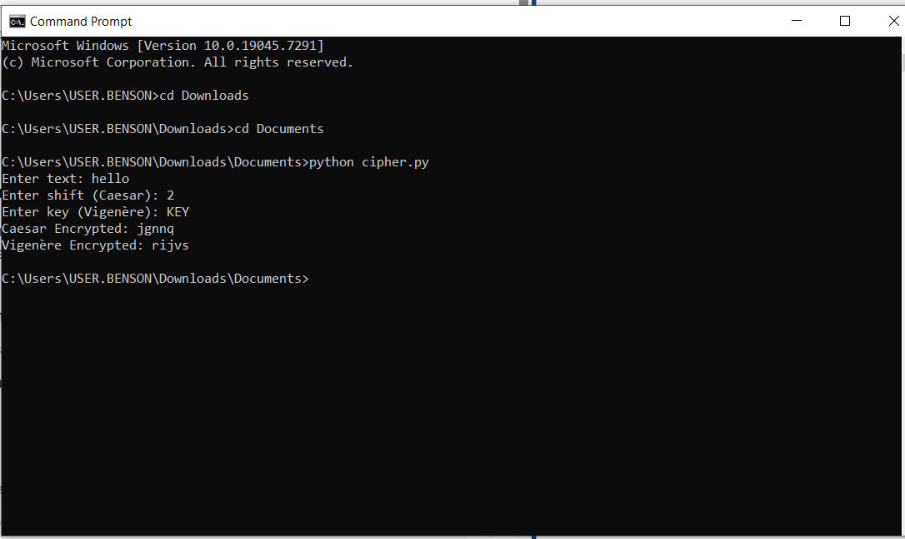

Fig 3: Encryption and Decryption Output
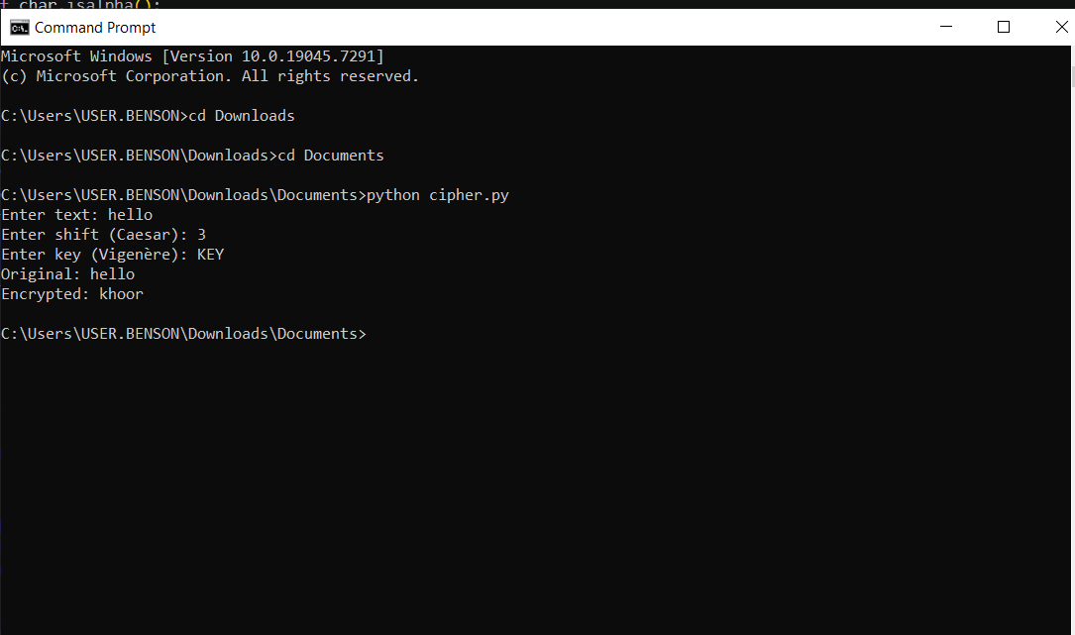

Fig 4: User Input Validation Interface
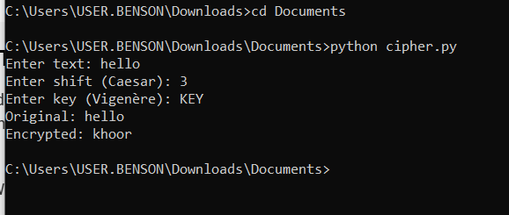

Fig 5: Cipher Testing Results
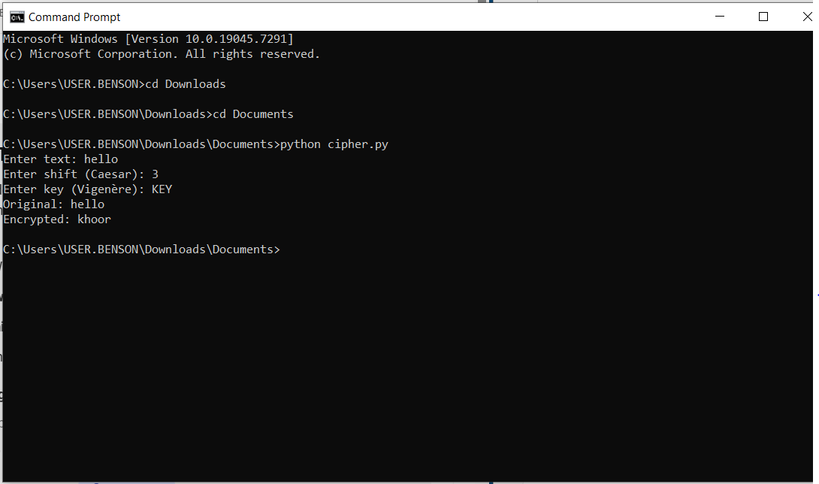

REFLECTION
The Vigenère Cipher implementation demonstrates how encryption algorithms transform plaintext into secure ciphertext. It shows the importance of keys in strengthening security and the overall encryption workflow. Weaknesses include simple ciphers being vulnerable to attacks, highlighting the need for stronger cryptographic methods like Vigenère.

Week 3: Stream Ciphers and Randomness Testing
Title: Implementation of Stream Cipher Systems and Random Sequence Analysis
Fig 1: LFSR Generator Implementation
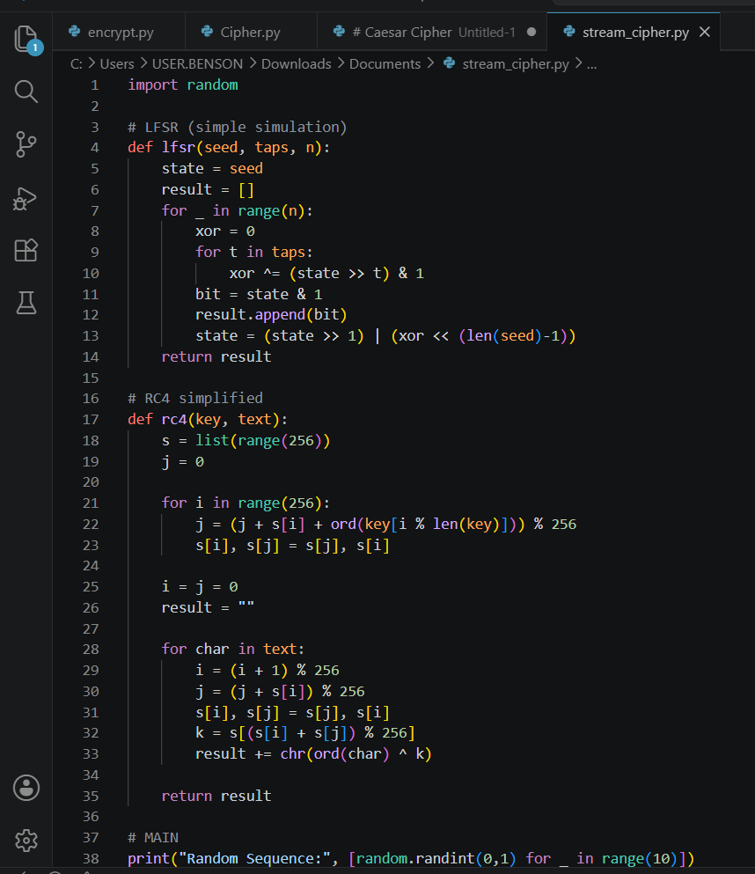

Fig 2: Pseudorandom Sequence Output
Fig 3: Statistical Randomness Testing
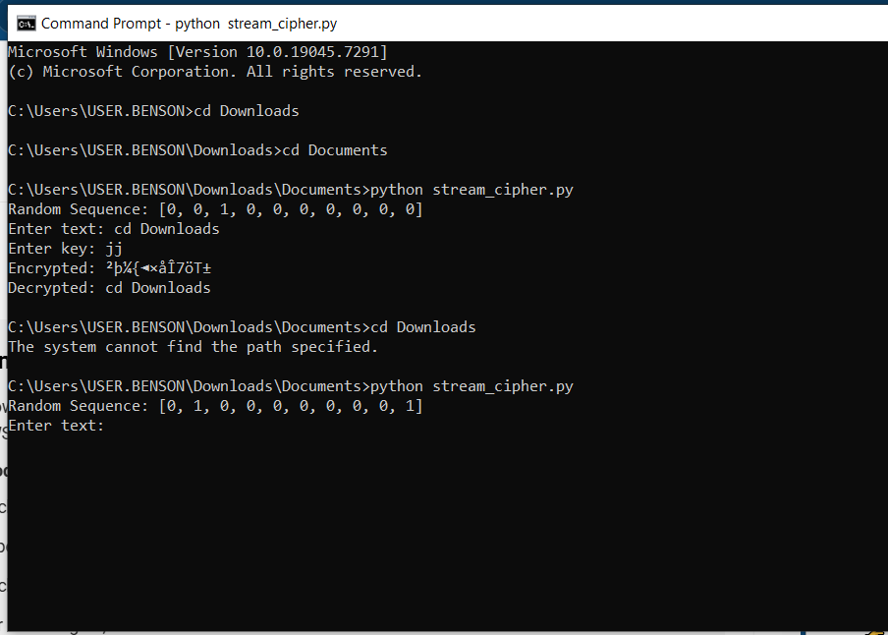

Fig 4: RC4 Stream Cipher Simulation
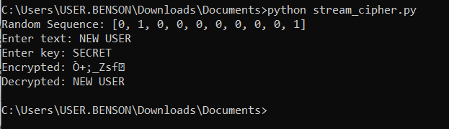
Fig 5: Encryption Performance Results


Reflection
This project demonstrated the importance of randomness in cryptography and how stream ciphers like RC4 encrypt data bit-by-bit using a key. Statistical testing showed variability in generated sequences, emphasizing the role of pseudorandom generation in ensuring secure and unpredictable encryption.”

Week 4: Block Cipher Design and AES
Title: Advanced Encryption Standard (AES) and Block Cipher Operations

Fig 1: AES Encryption Script
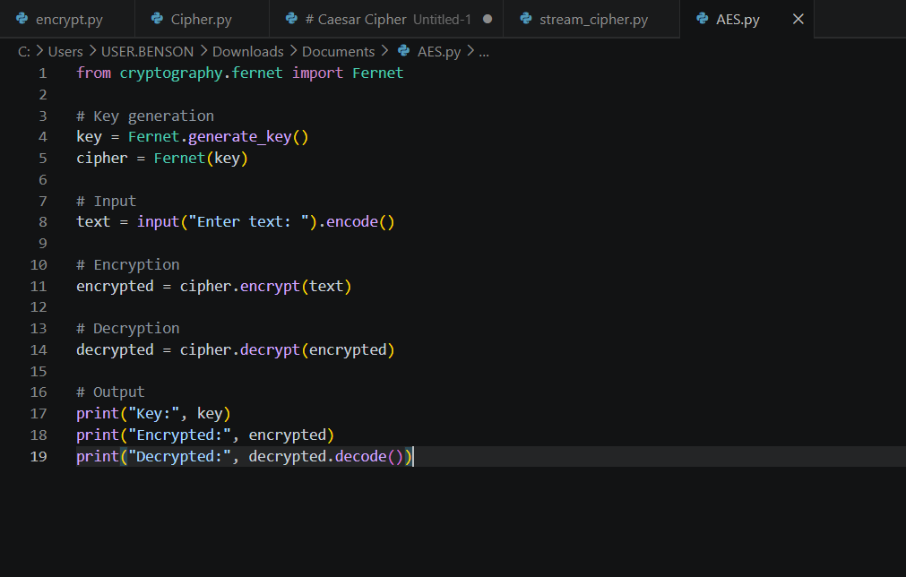
Fig 2: Key Generation Process
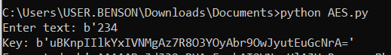
Fig 3: File Encryption Demonstration
Fig 4: Decryption Results
Fig 5: AES Performance Testing
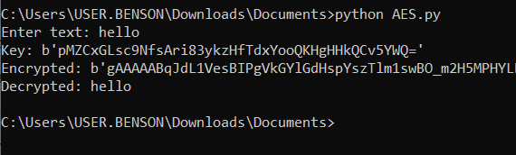

REFLECTION
This AES workflow demonstrated secure encryption and decryption using symmetric keys. Key security is essential to protect data from unauthorized access. This process involved converting plaintext to ciphertext and back. Challenges included installation issues and understanding command usage.

Week 5: Public Key Cryptography (RSA)
Title: Implementation of RSA Encryption and Key Management

Fig 1: RSA Key Pair Generation
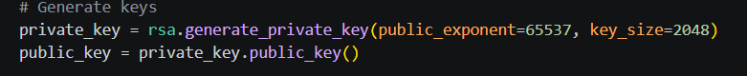
Fig 2: Public Key Encryption Process
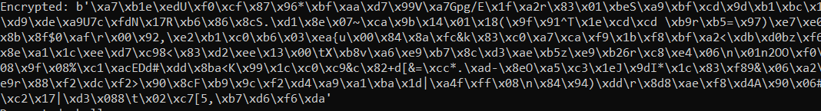
Fig 3: Private Key Decryption Results
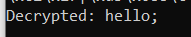
Fig 4: Secure Message Transmission
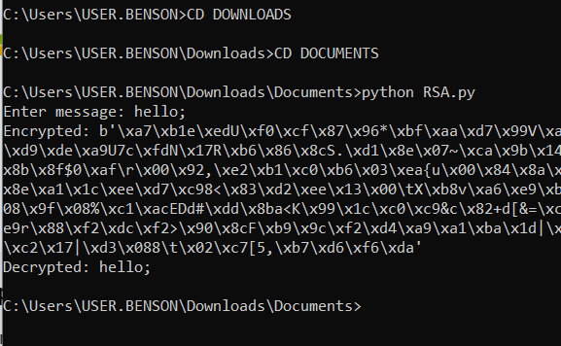
Fig 5: RSA Testing and Validation
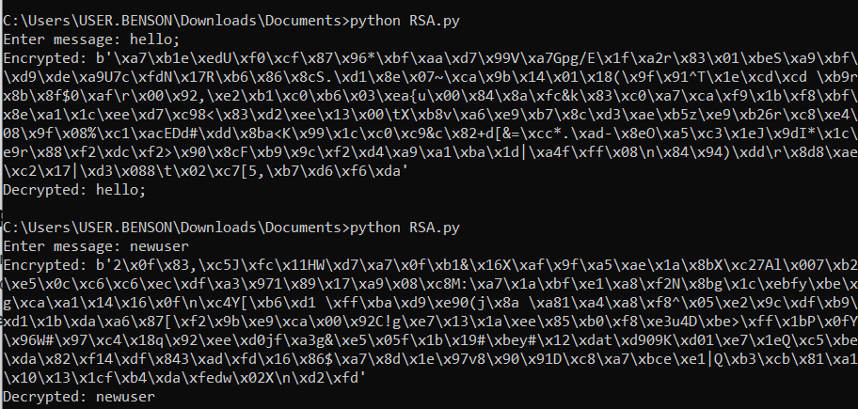

REFLECTION
It showed how asymmetric encryption differs from symmetric by using separate public and private keys. RSA improves security through key separation. Testing confirmed secure encryption with the public key and accurate decryption with the private key, demonstrating its effectiveness for secure communication.

